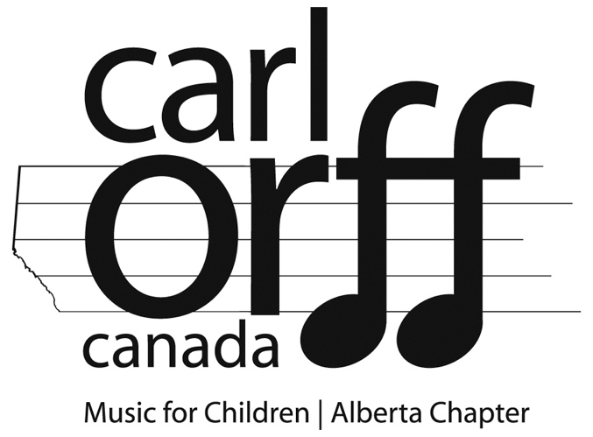

Alberta Orff Chapter:

Chapter President’s Award

Scholarship Application Form

Due: June 1 $500

Personal Information
Name:
Address:
Email:
Phone:

Course Information
Proposed Course:
Institution:
Dates of Course:
Present Chapter Affiliation:

Educational History
List educational institutions attended in chronological order, beginning with the most recent. Include any degrees or diplomas obtained.

Professional Experience
List any teaching positions, in chronological order, beginning with the most recent.

Orff Training & Experience
List previous Orff training and experience. Include the year it was completed, location, institutions and instructors.
Level I:
Level II:
Level III:
Other (please explain):

How long have you been a member of Carl Orff Canada?
What Orff workshops have you attended in the past three years?

Other Sources of Funding
Are you applying for or have you received funding from any other sources?

If Yes, please explain:

Other Required Documents
In addition to the completed application form, please submit:
scanned copy of certificate of completion and record of achievement for previous Orff Levels classes taken

current resume, cover letter indicating why are you applying for the scholarship, your educational background, your musical background, and what you hope to gain from the course

Two letters of reference from any of the following: administrator, superintendent, music education instructor, previous Orff Levels instructor, supervising teacher, etc

Further Information
- Incomplete applications will result in the candidate’s disqualification.
- Paper applications will not be accepted. Scanned/Digital applications only, please.
- Applications are due June 1 annually.
- Submit all inquiries, applications and documents to:
past-president@albertaorff.ca

