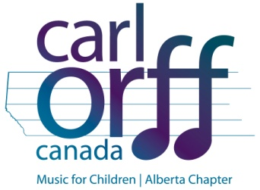
JOYCE OLIVER SCHOLARSHIP APPLICATION FORM

Joyce Oliver was a music educator and strong supporter of the arts in Edmonton. In her honor, the Alberta Chapter of Carl Orff Canada is offering a scholarship in her name. Simply fill out the form below explaining why your school should receive the Joyce Oliver Scholarship. The successful school will be $100 to go towards their school’s Music Program.

Name: ______________________________________________________________

School: _____________________________________________________________

____________________________________________________________________________________________________________________________________________________________________________________________________________________________________________________________________________________________________________________________________________________________________________________________________________________________________________________________________________________________________________________________________________________________________________________________________________________________________________________________________________________________________________________________________________________________________________________________________________________________________________________________________________________________________________________________________________________________________________________________________________________________________________________________________________________________________________________________________________________________________________________________________________________________________________________________________________________________________________________________________________________________________________________________________________________________________________________________________________________________________

