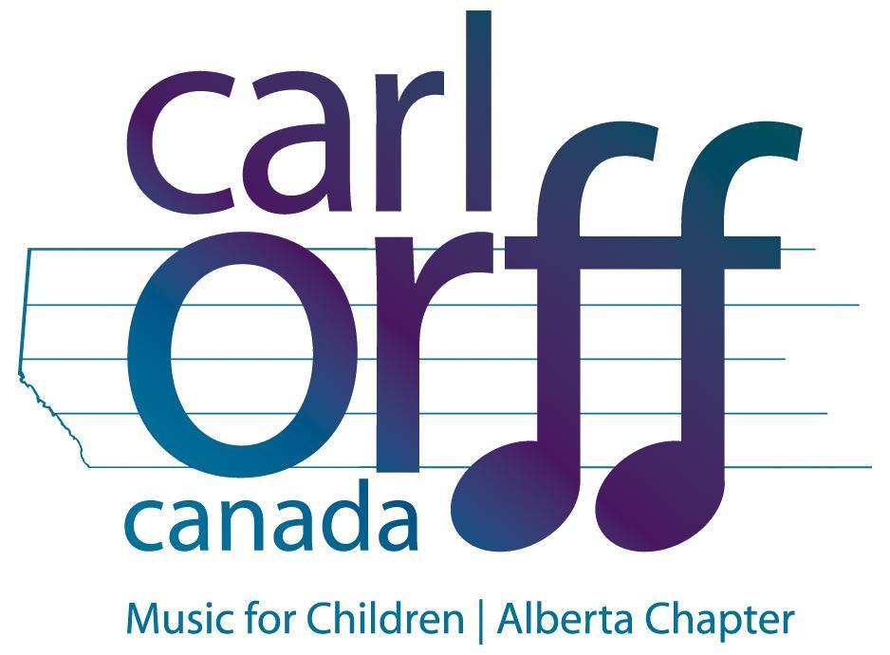

February 1, 2017

Dear Teachers,

This letter is information for teachers who are registering students for the April 24th Children’s Day event at the Winspear Centre. Teachers who are attending this unique PD opportunity without students attending will go directly to the AB Orff Chapter website to register as they would for any other workshop.

There is limited space for 60 students to attend this opportunity so please register students early for this event!

To support school music programs, the Alberta Orff Chapter is pleased to offer a $100 award to one school bringing students to this event. Please fill out the Joyce Oliver Award form found on the Children’s Day page at www.albertaorff.ca to apply for the scholarship.

We also encourage teachers to provide their principals with the advocacy letter provided on the web-site.

Student Registration:
Each school can register up to five students in grades 5 or 6. Teachers wishing to bring students to Children’s Day must hold a current membership with Carl Orff Canada and be registered to attend the workshop themselves.

- Complete the online School Registration Form and payment. Check website under the Children’s Day Tab.
- Print Student Registration Forms for each student attending at www.albertaorff.ca (look under “Children’s Day.”). Send home to be completed by parent/guardian.
- Once you have received the Student Registration Forms back from parents, please forward arcgivist@albertaorff.ca OR mail to:
Children’s Day Registration
c/o 11632 127 St
Edmonton Alberta
T5M OV5
- You will receive email confirmation of registration. Student registrations will be confirmed on a first come, first paid basis.
- Please note: Because this event is on a school day, students may be required to provide a field trip consent form (check with your administration).
- If you have any difficulty with registration or have any questions, please contact arcgivist@albertaorff.ca
All student registrations must be received by March 20, 2017.
We anticipate this event will fill up quickly! please register early. Registrations will be confirmed by April 14, 2015.

Teacher Workshop Registration:
- Visit www.albertaorff.ca (look under Children’s Day) to register online for this workshop.
- See our Advocacy Letter for assistance in securing funds to register.
- NOTE: If you paid a workshop subscription in the fall, this event is included.

Transportation Options
In order to transport students to children’s day, at the Winspear Center you might consider the options:

- Public Transportation: ETS Day pass http://www.edmonton.ca/transportation/ets/fares/day-pass.aspx
- Taxi Cab (Van cabs can transport up to 6 people)
- Have parents transport their child to and from the Winspear
- Volunteer Drivers (check your school’s policy)

Schedule for the Day
For your reference, here is the student itinerary for the day:
9:00 am - 9:15 am Arrival at Winspear Centre-Enter through Stage Door
9:15 am - 9:30 am Welcome, Announcement, Children warm-up with Doug Goodkin
9:30 am - 10:45 am Session 1
10:45 am - 11:00 am Break and Snack Time
11:00 am - 12:15 am Session 2
12:15 am - 1:00 pm Lunch
12:00 pm - 2:00 pm Whole Group Rehearsal for the Children’s Performance
2:00 pm - 2:15 pm Children’s Performance (parents and other audience welcome)
2:15 pm - 2:30 pm Students Pack Up and Leave

Teachers will have a special catered lunch provided by Elm Café. In addition, teachers will have a special session and small reception with Doug Goodkin following the children’s portion of the day which will end at 3:30.

Please provide names of parent volunteers or potential audience members to arcgivist@albertaorff.ca so that these guests may enter into the WInspear with ease.

The Alberta Orff Chapter and the Winspear Centre see this event as an important vehicle to advocate for quality music education for all students. Thank you for your part in helping to make this event a success!

Sincerely,

The Alberta Orff Children’s Day Committee

